**Name-Himanshi Sec-D Course-B.Tech U.Roll No-1918372**

**Objective #1 : : Write a program in java to print Hello Java using command prompt.**

**SOURCE CODE**

class A {

public static void main(String args[]) {

System.out.println("HELLO JAVA ");

}

}

**OUTPUT**

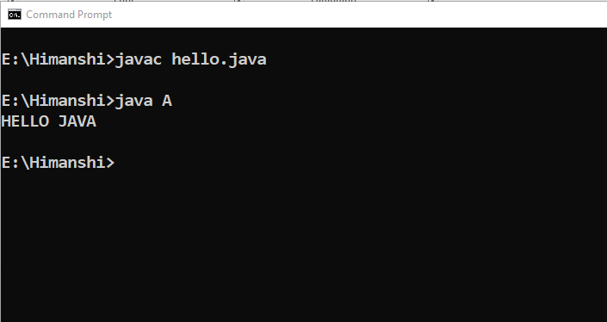

**Name-Himanshi Sec-D Course-B.Tech U.Roll No-1918372**

**Objective #2 : : Write a program in java to demonstrate the method which creates the object of the class.**

**SOURCE CODE**

class student{

String name;

int age;

char section;

double average;

void get_info(String n,int a,char sec,double avg){

name=n;

age=a;

section=sec;

average=avg;

}

void print(){

System.out.println("Name is "+name);

System.out.println("Age is "+age);

System.out.println("Section is "+section);

System.out.println("Average is "+average);

}

}

class B{

public static void main (String args[]){

student obj = new student();

obj.get_info("Himanshi",18,'D',95.4);

obj.print();

}

}

**OUTPUT**

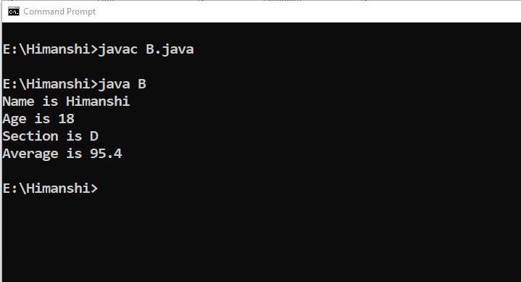

**Name-Himanshi Sec-D Course-B.Tech U.Roll No-1918372**

**Objective #3 : : Write a program in java to design a calculator which performs addition , subtraction, multiplication and division using switch statements .**

**SOURCE CODE**

import java.util.*;

class C{

public static void main(String args[]){

Scanner sc = new Scanner (System.in);

do{

System.out.println("Enter two number for operations ");

double a=sc.nextDouble();

double b=sc.nextDouble();

double result=0.0;

System.out.println("Enter the operation you want to perform");

System.out.println("Press 1 to Add ");

System.out.println("Press 2 to Subtract ");

System.out.println("Press 3 to Multiply ");

System.out.println("Press 4 to Divide ");

System.out.println("Press 5 to Quit ");

int opt=sc.nextInt();

switch (opt){

case 1:

result= a+b;

System.out.println("Addition is "+result);

break;

case 2:

result = a-b;

System.out.println("Result is "+result);

break;

case 3:

result = a*b;

System.out.println("Result is "+result);

break;

case 4:

result = a/b;

System.out.println("Result is "+result);

break;

default :

System.out.println("Wrong option");

case 5:

return;

}

}while(true);

}

}

**OUTPUT**

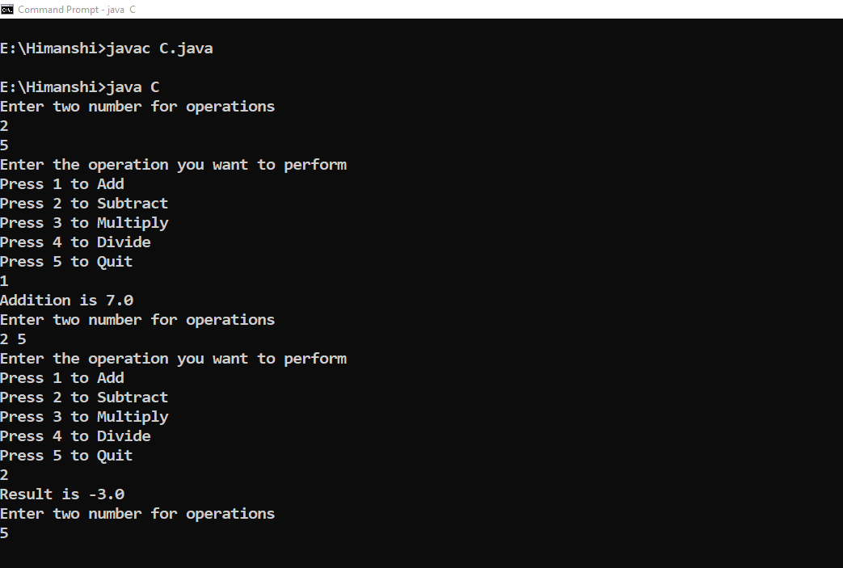

**Name-Himanshi Sec-D Course-B.Tech U.Roll No-1918372**

**Objective #4 Write a program in java to find out the factorial of a number using class and methods.**

**SOURCE CODE**

import java.util.*;

class find_fact{ int n;

void initialise(int number){

n=number;

}

long factorial(int n){

if (n == 0)

return 1;

else

return(n * factorial(n-1));

}

}

class prog4{ public static void main(String args[]){

Scanner sc = new Scanner(System.in);

System.out.println("Enter the number ");

int inp=sc.nextInt();

find_fact obj= new find_fact();

obj.initialise(inp);

long result=obj.factorial(inp);

System.out.println("Factorial is "+result);

}

}

**OUTPUT**

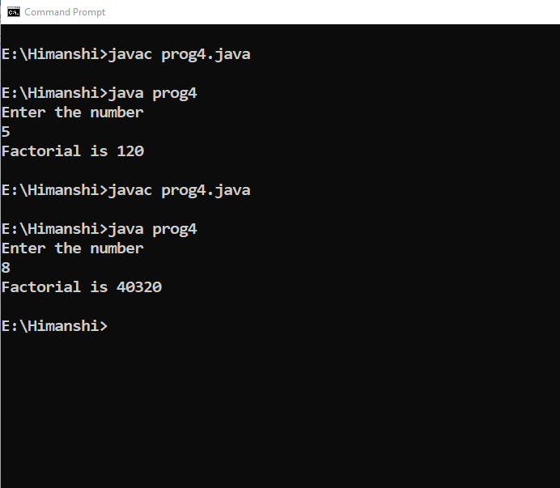

**Name-Himanshi Sec-D Course-B.Tech U.Roll No-1918372**

**Objective #5:: Write a program in java to find out the sum of the series ::**

**1/2! + 2/3! + 3/4! +. . . . . . . . . . . . . . . . . n/(n+1) !.**

**SOURCE CODE**

import java.util.*;

class prog5{

public static void main(String args[]){

Scanner sc = new Scanner (System.in);

System.out.println("Enter the limit for series");

int n= sc.nextInt();

double sum=0.0;

for (int i=1;i<=n;i++){

double vv=(double )i/facto(i+1);

sum+=vv;

vv=0;

}

System.out.println("Sum of series is "+sum);

}

public static int facto(int n){

if (n == 0)

return 1;

else

return(n * facto(n-1));

} }

**OUTPUT**

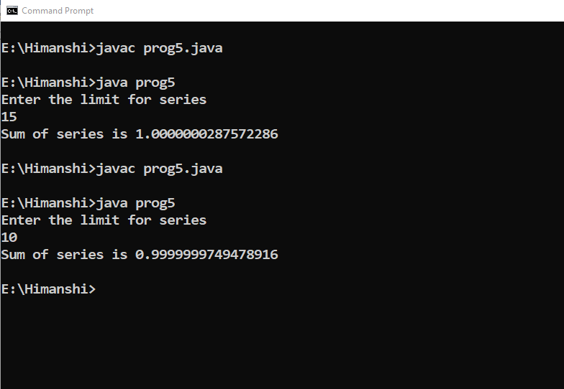

**Name-Himanshi Sec-D Course-B.Tech U.Roll No-1918372**

**Objective #6 :Write a program in java to check whether the character is vowel or consonant .**

**SOURCE CODE**

import java.util.Scanner;

class prog6{

public static void main(String args[]) {

int i=0;

Scanner sc=new Scanner(System.in);

System.out.println("Enter a character to be checked : ");

char ch=sc.next( ).charAt(0);

if(ch=='a'||ch=='e'||ch=='i'||ch=='o'||

ch=='u'||ch=='A'||ch=='E'||ch=='I'||

ch=='O'||ch=='U')

{

System.out.println("VOWEL");

}

else if((ch>='a'&&ch<='z')||(ch>='A'&&ch<='Z'))

System.out.println("CONSONANT");

else

System.out.println("Wrong entered :: ");

}

}

**OUTPUT**

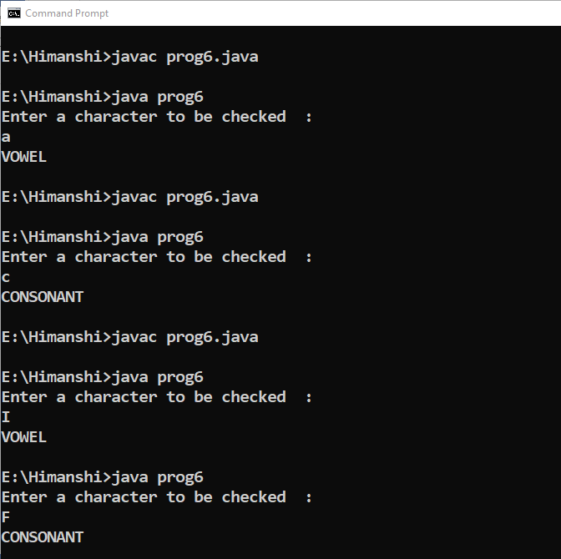

**Name-Himanshi Sec-D Course-B.Tech U.Roll No-1918372**

**Objective #7: Write a program in java to check demonstrate different methods which accept input from the user using command line arguments .**

**SOURCE CODE**

class prog7{

public static void main(String args[]){

int input,sum=0;

for (int i=0;i<5;i++){

input=Integer.parseInt(args[i]);

sum+=input;

}

System.out.println("Sum is "+sum);

}

}

**OUTPUT**

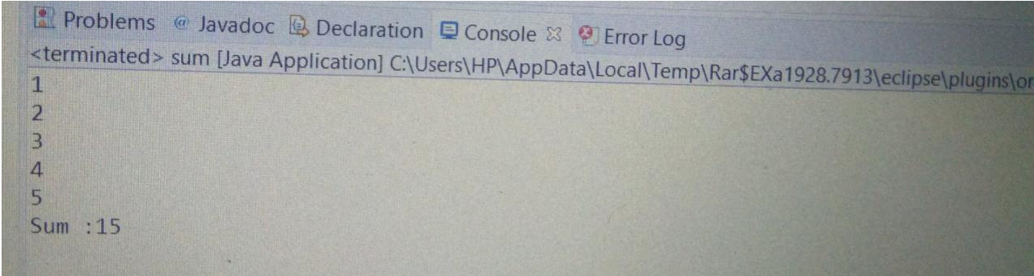

**Name-Himanshi Sec-D Course-B.Tech U.Roll No-1918372**

**Objective #8::Write a program in java to check demonstrate different methods which accept input from the user using Scanner class.**

**SOURCE CODE**

import java.util.*;

class prog8{

public static void main(String args[]){

Scanner sc = new Scanner(System.in);

System.out.println("Enter the limit");

int inp,sum=0;

int limit=sc.nextInt();

for (int i=0;i<limit;i++){

System.out.println("Enter "+(i+1)+"th number");

inp=sc.nextInt();

sum+=inp;

}

System.out.println("Sum is "+sum);

}

}

**OUTPUT**

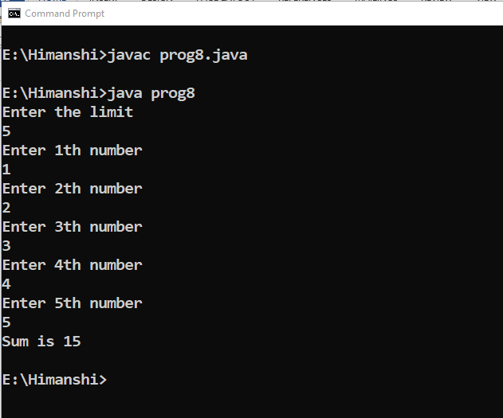

**Name-Himanshi Sec-D Course-B.Tech U.Roll No-1918372**

**Objective #9::Write a program in java to check demonstrate different methods which accepts input from the user using BufferReader class.**

**SOURCE CODE**

import java.io.*;

class prog9{

public static void main(String args[]) throws IOException{

InputStreamReader h= new InputStreamReader(System.in);

BufferedReader br = new BufferedReader(h);

System.out.println("Enter the limit");

int inp,sum=0;

int limit=Integer.parseInt(br.readLine());

for (int i=0;i<limit;i++){

System.out.println("Enter "+(i+1)+"th number");

inp=Integer.parseInt(br.readLine());

sum+=inp;

}

System.out.println("Sum is "+sum);

}

}

**OUTPUT**

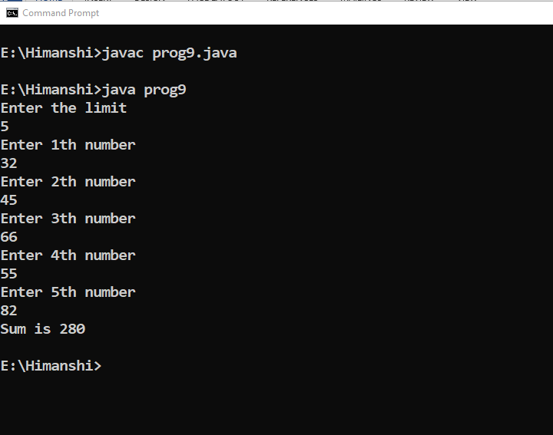

**Name-Himanshi Sec-D Course-B.Tech U.Roll No-1918372**

**Objective #10::Write a program in java to find volume of the box using methods and use of scanner class .**

**SOURCE CODE**

import java.util.*;

class dim{

double length;

double breadth;

double height;

void get_dimension(double l ,double b, double h){

length=l;

breadth=b;

height=h;

}

double calculate_volume(){

return length*breadth*height ;

}

void display_all(){

System.out.println("Length is :: "+length);

System.out.println("Breadth is :: "+breadth);

System.out.println("Height is :: "+height);

System.out.println("Volume is :: "+ calculate_volume());

}

}

class prog10{

public static void main (String args[]){

Scanner sc = new Scanner (System.in);

dim obj = new dim();

System.out.println("Enter the length");

int length=sc.nextInt();

System.out.println("Enter the breadth");

int breadth=sc.nextInt();

System.out.println("Enter the height");

int height=sc.nextInt();

obj.get_dimension(length,breadth,height);

obj.calculate_volume();

obj.display_all();

}

}

**OUTPUT**

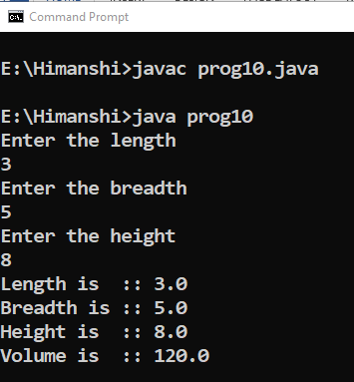

**Name-Himanshi Sec-D Course-B.Tech U.Roll No-1918372**

**Objective #11::Write a program in java to demonstrate the use of default constructor.**

**SOURCE CODE**

import java.util.*;

class dimensions{

double length;

double breadth;

double height;

dimensions(){ //Default Constructor

System.out.println ("Reached in default constructor");

length=12.2;

breadth=10.0;

height=2;

}

double calculate_volume(){

return length*breadth*height ;

}

void display_all(){

System.out.println("Length is :: "+length);

System.out.println("Breadth is :: "+breadth);

System.out.println("Height is :: "+height);

System.out.println("Volume is :: "+ calculate_volume());

}

}

class prog11{

public static void main (String args[]){

dimensions obj = new dimensions();

obj.display_all();

}

}

**OUTPUT**

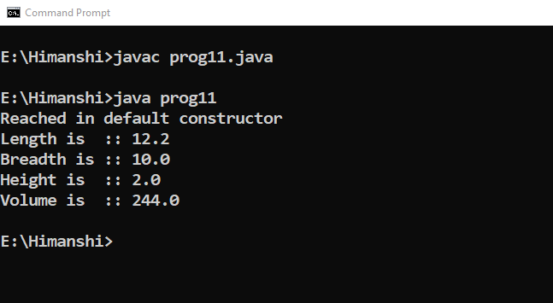

**Name-Himanshi Sec-D Course-B.Tech U.Roll No-1918372**

**Objective #12::Write a program in java to demonstrate the use of parameterized constructor.**

**SOURCE CODE**

class pts{

double length;

double breadth;

double height;

pts(double l ,double b, double h){

length=l;

breadth=b;

height=h;

}

double calculate_volume(){

return length*breadth*height ;

}

void display_all(){

System.out.println("Length is :: "+length);

System.out.println("Breadth is :: "+breadth);

System.out.println("Height is :: "+height);

System.out.println("Volume is :: "+ calculate_volume());

}

}

class prog12{

public static void main (String args[]){

pts obj = new pts(2,3,4);

obj.display_all();

}

}

**OUTPUT**

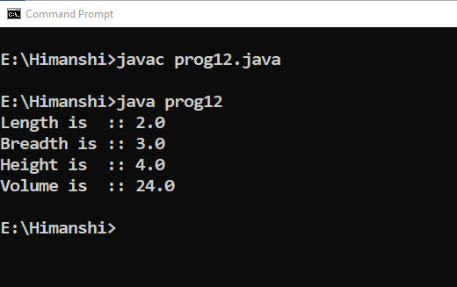

**Name-Himanshi Sec-D Course-B.Tech U.Roll No-1918372**

**Objective #::13Write a program in java to demonstrate the use of this keyword.**

**SOURCE CODE**

class student{

String name;

int age;

double avg;

char ch;

void get_everything(String name,int age,double avg,char ch){

this.name=name;

this.age=age;

this.avg=avg;

this.ch=ch;

}

void print_details(){

System.out.println("Name of the student :: "+name);

System.out.println("Age of the student :: "+age);

System.out.println("Average marks of the student :: "+avg);

System.out.println("Section is "+ch);

}

}

class prog13 {

public static void main(String args[]) {

student obj = new student();

obj.get_everything("Himanshi ",18,95.56,'D');

obj.print_details();

}

}

**OUTPUT**

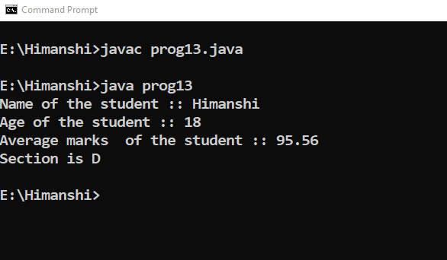

**Name-Himanshi Sec-D Course-B.Tech U.Roll No-1918372**

**Objective #14::Write a program in java to demonstrate the use of copy constructor .**

**SOURCE CODE**

class in{

double length;

double breadth;

double height;

in(double length ,double breadth, double height){

this.length=length;

this.breadth=breadth;

this.height=height;

}

in (in obj){

System.out.println("Reached in copy constructor");

this.length=obj.length;

this.breadth=obj.breadth;

this.height=obj.height;

}

double calculate_volume(){

return length*breadth*height ;

}

void display_all(){

System.out.println("Length is :: "+length);

System.out.println("Breadth is :: "+breadth);

System.out.println("Height is :: "+height);

System.out.println("Volume is :: "+ calculate_volume());

}

}

class prog14{

public static void main (String args[]){

in obj = new in(8,5,6);

in obj1=new in (obj);

obj.display_all();

}

}

**OUTPUT**

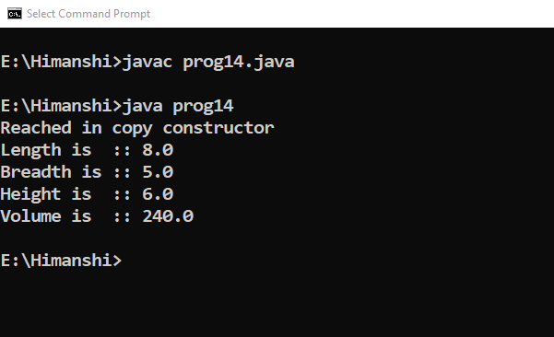

**Name-Himanshi Sec-D Course-B.Tech U.Roll No-1918372**

**Objective #15::Write a program in java to perform constructor overloading and find out the volume of the three different boxes .**

**SOURCE CODE**

import java.util.*;

class over{

double length;

double breadth;

double height;

over(){

length=5.2;

breadth=3.4;

height=4.5;

}

over (double length,double breadth , double height){

this.length=length;

this.breadth=breadth;

this.height=height;

}

over (double one){

length=breadth=height=one;

}

double calculate(){

return length*breadth*height;

}

void display(){

System.out.println("Length is "+length);

System.out.println("Breadth is "+breadth);

System.out.println("Height is "+height);

System.out.println("Volume is "+calculate());

System.out.println("");

}

}

class prog15{

public static void main(String args[]){

Scanner sc = new Scanner(System.in);

over obj = new over();

System.out.println("First Box");

obj.display();

System.out.println("Second Box:: ");

System.out.println("Enter Length ::");

double length=sc.nextInt();

System.out.println("Enter Breadth ::");

double breadth=sc.nextInt();

System.out.println("Enter Height ::");

double height=sc.nextInt();

over obj1=new over(length,breadth,height);

obj1.display();

System.out.println("Third Box :: Let all three sides be equal");

System.out.println("Enter size");

double one=sc.nextInt();

over obj2= new over(one);

obj2.display();

}

}

**OUTPUT**

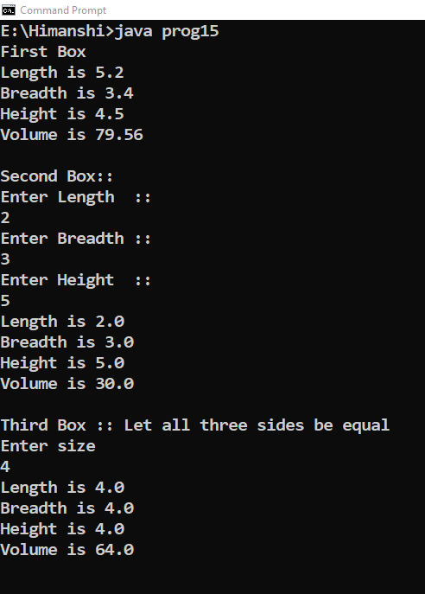

**Name-Himanshi Sec-D Course-B.Tech U.Roll No-1918372**

**Objective #16::Write a program in java find out area of three different figures using constructor overloading concept.**

**SOURCE CODE**

import java.util.Scanner;

class figures{

double base,height,half;

double length,breadth;

double radius;

figures(double base,double height,double half){

this.base=base;

this.height=height;

this.half=half;

}

figures(double length,double breadth){

this.length=length;

this.breadth=breadth;

}

figures(double radius) { this.radius=radius; }

double area_of_triangle() { return (0.5*base*height); }

double area_of_rectangle() {return length*breadth; }

double area_of_circle() { return (3.1415926535*radius*radius); }

void display_triangle(){

System.out.println("Area of triangle is "+area_of_triangle());

}

void display_rectangle(){

System.out.println("Area of rectangle is "+area_of_rectangle());

}

void display_circle(){

System.out.println("Area of circle is "+area_of_circle());

}

}

class prog16{

public static void main(String args[]){

Scanner sc = new Scanner (System.in);

char ch;

do{

System.out.println("Choose one option ::");

System.out.println("Hit c for area of circle ::");

System.out.println("Hit r for area of rectangle ::");

System.out.println("Hit t for area of triangle ::");

System.out.println("Hit q to quit ::");

ch =sc.next().charAt(0);

switch (ch){

case 'c':

System.out.println("Enter the radius ::");

double radius=sc.nextDouble();

figures obj = new figures(radius);

obj.display_circle();

break;

case 'r':

System.out.println("Enter the length and breadth ::");

double length=sc.nextDouble();

double breadth=sc.nextDouble();

figures obj1 = new figures(length,breadth);

obj1.display_rectangle();

break;

case 't':

System.out.println("Enter the base and height ::");

double base=sc.nextDouble();

double height=sc.nextDouble();

double half=0.5;

figures obj2 = new figures(base,height,half);

obj2.display_triangle();

break;

default:

break;

}

}while (ch!='q');

}

}

**OUTPUT**

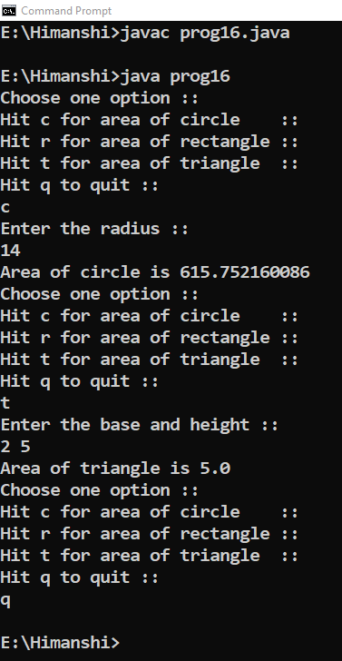

**Name-Himanshi Sec-D Course-B.Tech U.Roll No-1918372**

**Objective #17::A class telcall calculates the monthly phone bill of a subscriber .**

**Some member functions are given below ::**

* **phno-> To store phone number of the subscriber.**
* **sname -> To store subscriber’s name.**
* **n-> To store the number of calls made by the subscriber.**
* **amt-> Total Bill Amount.**

**Telcall : parameterized constructor to assign values to data members.**

**void compute()-> To calculate the phone bill amount based on the**

**pricing given below.**

**void display()-> To display the details in the specified format.**

|  |  |  |
| --- | --- | --- |
| **S.no** | **Number of calls** | **Rate (in INR)** |
| **1** | **1-100** | **500 rental charges only.** |
| **2** | **101-200** | **1/call + rental charge.** |
| **3** | **201-300** | **1.20/call +rental charge.** |
| **4** | **Above 300** | **1.50/call +rental charge.** |

**SOURCE CODE**

import java.util.*;

class telcall{

String sname;

int n;

double amt;

long phno;

telcall(String sname,long phno,int n){

this.sname=sname;

this.n=n;

this.phno=phno;

}

double compute(int n){

double am=0.0;

if (n<100){

am+=500;

}

else if (n<200){

am+=500+(1*n);

}

else if (n<300){

am+=500+(1.2*n);

}

else {

am+=500+(1.5*n);

}

return am;

}

void display(){

System.out.println("Phone number is "+phno);

System.out.println("Subscriber name is "+sname);

System.out.println("Number of calls is "+n);

//System.out.println("Bill you have to pay is "+amt);

}

}

class prog17{

public static void main(String args[]){

Scanner sc = new Scanner (System.in);

String sname;

long phno;

int n;

System.out.println("Enter your name");

sname=sc.nextLine();

System.out.println("Enter you phone number excluding +91 ");

phno=sc.nextLong();

System.out.println("Enter the number of calls ");

n=sc.nextInt();

telcall obj=new telcall(sname,phno,n);

double amt=obj.compute(n);

obj.display();

System.out.println("Amount to be payed is "+amt);

}

}

**OUTPUT**

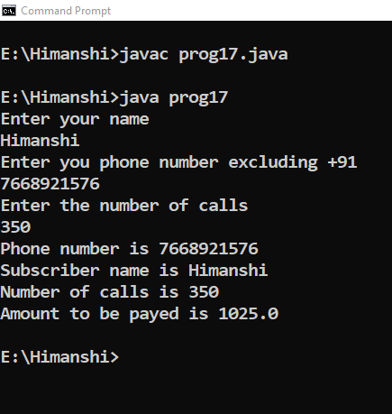

**Name-Himanshi Sec-D Course-B.Tech U.Roll No-1918372**

**Objective #18::Design a class to represent the bank account which includes the following:**

* **Assign initial values .**
* **Deposit the amount.**
* **To withdraw amount after checking balance.**
* **To display name and balance**

**Write a program in java with the use of constructor to provide initial values . Also use this keyword and instantiate it’s object.**

**SOURCE CODE**

import java.util.*;

class Bank {

Scanner sc = new Scanner (System.in);

String name,acc_type;

long acc,balance_amt,with,depo;

Bank(String name, String acc_type,long balance_amt){

this.name=name;

this.acc_type=acc_type;

this.balance_amt=balance_amt;

}

void deposit() {

System.out.print(" Enter amt to deposit : ");

depo =sc.nextInt();

balance_amt+=depo;

show();

}

void withdraw() {

System.out.println("\nEnter amt to withdraw : ");

with =sc.nextInt();

if(balance_amt-with>=100)

balance_amt=balance_amt-with;

else

System.out.println("You cannot withdraw....");

show();

}

void show() {

System.out.println("\nDepositor name :"+name);

System.out.println("Type of Account :"+acc_type);

System.out.println("Balance :"+balance_amt);

}

}

class prog18 {

public static void main(String args[ ]) {

Scanner sc = new Scanner (System.in);

char opt;

char ch;

Bank obj=new Bank("Himanshi","SAVINGS",922000);

obj.show();

do {

System.out.println("\n1. Deposit hit d");

System.out.println("2. Withdraw hit w ");

opt =sc.next().charAt(0);

if(opt =='d')

obj.deposit();

if(opt =='w')

obj.withdraw();

System.out.println("Stay safe Have a good day ahead ");

System.out.println("To continue press 1 or press any key and enter to end");

ch=sc.next().charAt(0);

}while(ch=='1');

}

}

**OUTPUT**

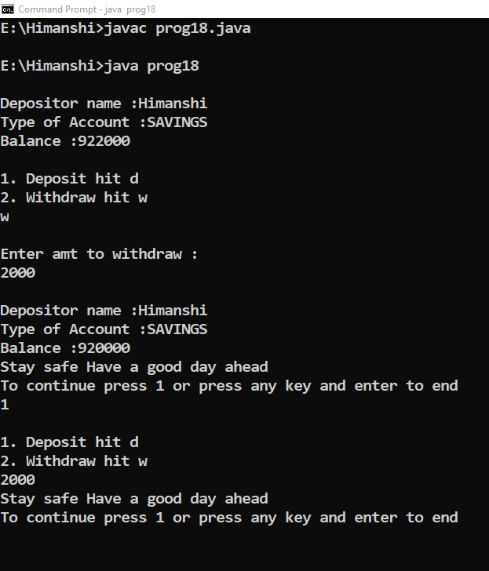

**Name-Himanshi Sec-D Course-B.Tech U.Roll No-1918372**

**Objective #19 : Write a program in java to use the static keyword in a variable.**

**SOURCE CODE**

import java.util.*;

class Student{

int rollno;

String name;

static String college ="Graphic Era Hill University";

Student(int r, String n){

rollno = r;

name = n;

}

void display (){System.out.println(rollno+" "+name+" "+college);}

}

public class prog19{

public static void main(String args[]){

Student s1 = new Student(12,"Himanshi");

Student s2 = new Student(13,"Mansi");

s1.display();

s2.display();

}

}

**OUTPUT**

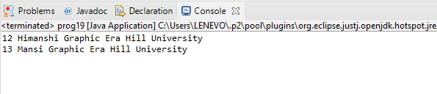

**Name-Himanshi Sec-D Course-B.Tech U.Roll No-1918372**

**Objective #20 : Write a program in java to maintain the data of different students with a single university name with the help of static keyword.**

**SOURCE CODE**

**Name-Himanshi Sec-D Course-B.Tech U.Roll No-1918372**

**Objective #21 : Write a program to demonstrate the use of static method.**

**SOURCE CODE**

package practical;

class prog20 {

static {

System.*out*.println("Java is my favourite Language");

System.*exit*(0);;

}

public static void main(String args[]) {

System.*out*.println("main worked");

}

}

**OUTPUT**

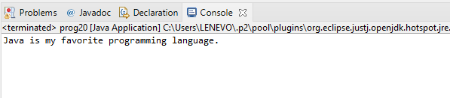

**Name-Himanshi Sec-D Course-B.Tech U.Roll No-1918372**

**Objective #22 : WAP in java to maintain a data for the employer- employee ID, name salary,( non static). Name of company, specialisation of the employee,( static). Methods are: get details, print details,( non-static). Change of fields (static). WAP that will accept from the user and print the details.**

**SOURCE CODE**

package practical;

import java.util.*;

class abc

{

String employee_name;

int employee_id;

double employee_salary;

static String *company*="reliance";

String field;

void getdetail()

{

System.*out*.println("enter the details of the employee");

Scanner sc=new Scanner(System.*in*);

employee_name=sc.nextLine();

employee_id=sc.nextInt();

employee_salary=sc.nextDouble();

field=sc.next();

}

static void change()

{

Scanner sc=new Scanner(System.*in*);

*company*=sc.next();

}

void printdetail()

{

System.*out*.println("printing the details");

System.*out*.println("employee_name :"+employee_name);

System.*out*.println("employee_id :"+employee_id);

System.*out*.println("employee_salary :"+employee_salary);

System.*out*.println("field :"+field);

System.*out*.println("company :"+*company*);

}

}

public class prog21 {

public static void main(String args[])

{

abc obj=new abc();

obj.getdetail();

System.*out*.println("want to change company enter yes or no :\n");

Scanner sc=new Scanner(System.*in*);

char ch;

ch=sc.next().charAt(0);

if(ch=='y')

{

System.*out*.println("enter the company name :\n");

abc.*change*();

obj.printdetail();

}

else

obj.printdetail();

}

}

**OUTPUT**

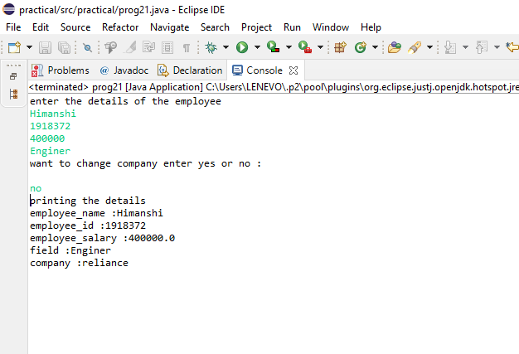

**Name-Himanshi Sec-D Course-B.Tech U.Roll No-1918372**

**Objective #23 : : Write a program in java find outh the vol.of box fof 5 different boxes.**

**SOURCE CODE**

package practical;

import java.util.Scanner;

class Box

{

double l,b,h,v;

Box(double l,double b,double h)

{

this.l=l;

this.b=b;

this.h=h;

}

void display()

{

System.*out*.println("the length is :"+l);

System.*out*.println("the breadth is :"+b);

System.*out*.println("the height is :"+h);

System.*out*.println("the volume is :"+volume());

}

double volume()

{

return l*b*h;

}

}

public class Program23

{

public static void main(String args[])

{

double p,q,r;

Box[] a;

a=new Box[5];

for(int i=0;i<5;i++)

{

System.*out*.println("Enter the Dimensions");

Scanner sc=new Scanner(System.*in*);

p=sc.nextDouble();

q=sc.nextDouble();

r=sc.nextDouble();

a[i]=new Box(p,q,r);

a[i].volume();

a[i].display();

}

}

}

**OUTPUT**

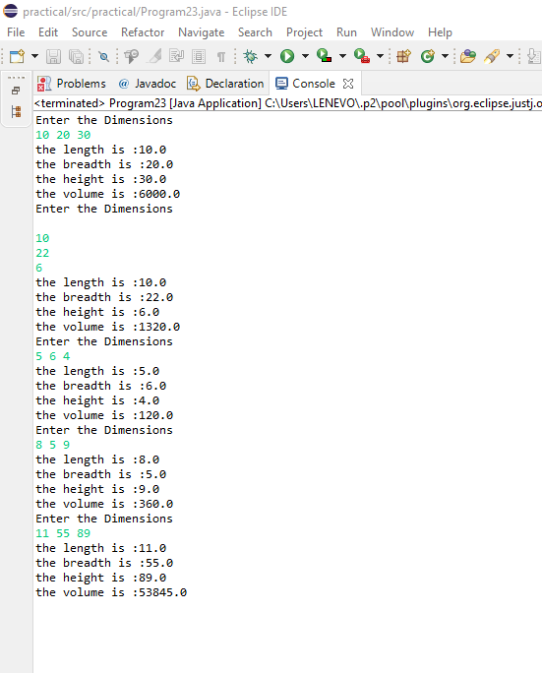

**Name-Himanshi Sec-D Course-B.Tech U.Roll No-1918372**

**Objective #24 : : Write a program in java to find out the average marks for 5 students with their name,age or fees.**

**SOURCE CODE**

**Name-Himanshi Sec-D Course-B.Tech U.Roll No-1918372**

**Objective #25 : : Wap in java to find out the sum of all array elements which are at even position using methods**

**SOURCE CODE**

package practical;

import java.io.*;

class program24 {

public static void main(String args[])

{

int arr[] = { 2,4,6,8,10,3,6,9,12,15};

int even = 0, odd = 0;

// Loop to find even, odd sum

for (int i = 0; i < arr.length; i++) {

if (i % 2 == 0)

even += arr[i];

else

odd += arr[i];

}

System.*out*.println("Even index positions sum: " + even);

System.*out*.println("Odd index positions sum: " + odd);

}

}

**OUTPUT**

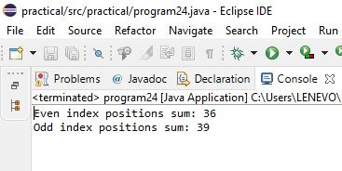

**Name-Himanshi Sec-D Course-B.Tech U.Roll No-1918372**

**Objective #26 : : Wap in java to insert an element after recognizing a specified key without altering the array elements.**

**SOURCE CODE**

package practical;

import java.util.*;

class shift {

Scanner sc=new Scanner(System.*in*);

int n,pos,c=0,temp;

int arr[]=new int[200];

public shift(int size) {

n=size;

System.*out*.println("Enter array elemnts");

for(int i=0;i<n;i++)

{

arr[i]=sc.nextInt();

}

}

int search(int key) {

for(int i=0;i<n;i++) {

if(arr[i]==key) {

System.*out*.println(key +" Found at position " + (i+1));

c=1;

pos =i;

}

}

if(c==0) {

System.*out*.println("Key not found");

}

return pos;

}

void insert(int index,int e) {

for(int i=n;i>=index;i--) {

arr[i+1]=arr[i];

}

arr[index]=e;

}

void print() {

System.*out*.println("Array after all the operations is ");

for(int i=0;i<n+61;i++) {

System.*out*.println(arr[i]);

}

}

}

public class prog25 {

public static void main(String args[]) {

Scanner sc=new Scanner(System.*in*);

int size;

System.*out*.println("Enter the size of array");

size=sc.nextInt();

shift obj=new shift(size);

System.*out*.println("Enter the key you wnat to search in the element");

int key = sc.nextInt();

int index = obj.search(key);

System.*out*.println("Enter the new element you want to insert in the array");

int ne=sc.nextInt();

obj.insert(index, ne);

obj.print();

}

}

**OUTPUT**

